**NCT Management User Manual**

Lennard glenn bandol - c14337331

**Login** **1**

**Admin Panel** **2**

**Create Appointment - A** **3**

**Create Appointment - B** **4**

**View Appointments** **5**

**Edit Appointment - A** **6**

**Edit Appointment - B** **7**

**Display Users List** **8**

**Create New User** **9**

**Display Tested Car List** **10**

**Display Tested Car Results** **11**

**Display Untested Part List** **12**

**Insert Part Results** **13**

# 

# 

# 

# 

# Login

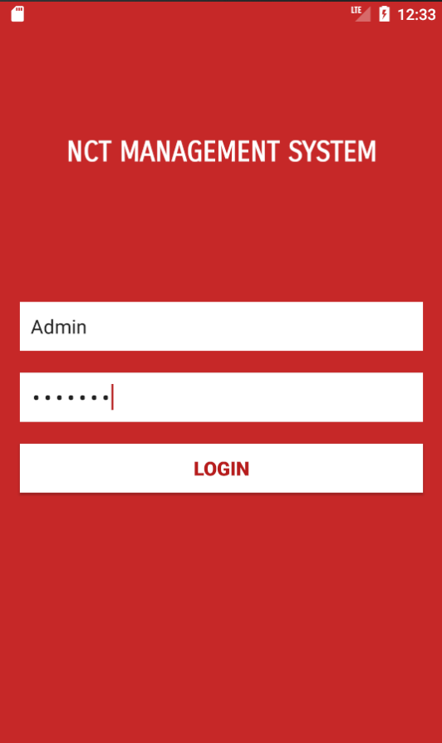

**Default Admin Account**

Username: Admin

Password: Admin

**Default Mechanic Account**

Username: Mechanic

Password: Mechanic

Enter Username and Password

Press Login Button

Employee will be directed to their appropriate panels.

# 

# Admin Panel

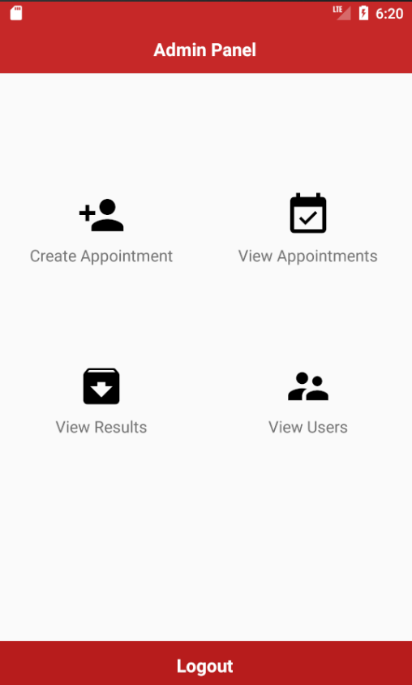

Press these buttons to bring you to their activity.

Create Appointment - Create New Appointment

View Appointment - Display All The Appointment

View Results - Display Car Results

View Users - Display The Users List

Logout - Log the users out

# Create Appointment - A

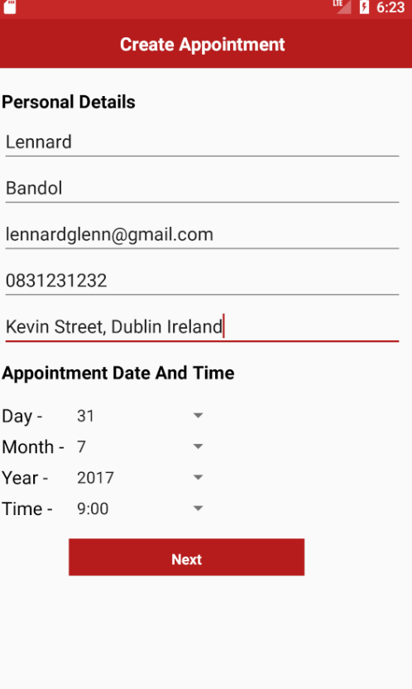

**Enter Customer Details**

First Name

Last Name

Email

Telephone

Address

**Choose Date and Time**

Day

Month

Year

Time ( Every 30 minutes from 9:00 to 17:00)

Also checks if the date and time is already booked

**Press Next Button**

Go to Enter Vehicle Detail

# Create Appointment - B

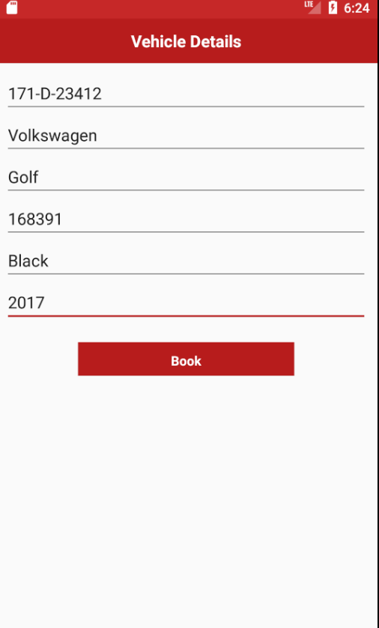

**Enter Vehicle Details**

Plate Number

Model

Make

Mileage

Color

Year

Make sure your car don't have appointment already.

**Press Book Button**

Completes Create Appointment

# View Appointments

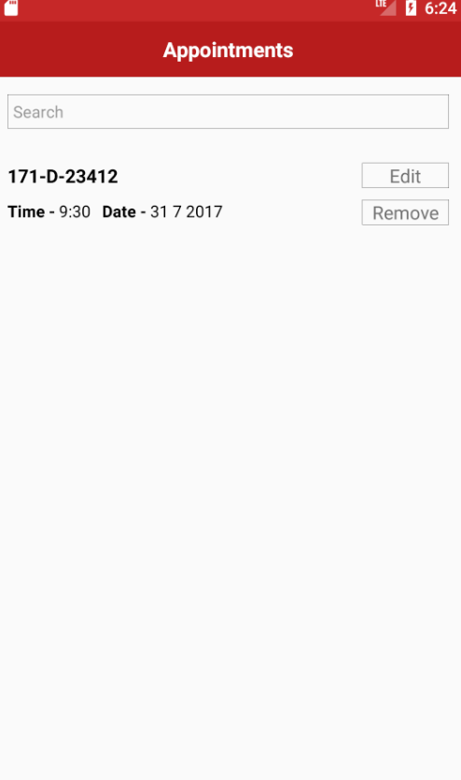

Displays a list of the Appointments

**Search Box**

Enter vehicle plate number to filter appointments

**Edit Button**

Press to edit the pressed appointment

**Remove Button**

Press to delete/cancel pressed appointment

# Edit Appointment - A



**Edit Customer Details**

First Name

Last Name

Email

Telephone

Address

**Change Date and Time**

Day

Month

Year

Time ( Every 30 minutes from 9:00 to 17:00)

Also checks if the date and time is already booked

**Press Next Button**

Go to Enter Vehicle Details

# Edit Appointment - B



**Change Vehicle Details**

Plate Number

Model

Make

Mileage

Color

Year

**Press Book Button**

Completes Appointment Changes

# Display Users List

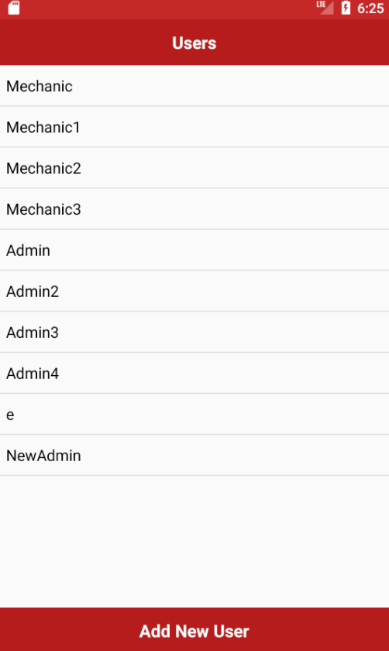

Shows List of Users

**Add New User Button**

Press to create a new user

# Create New User

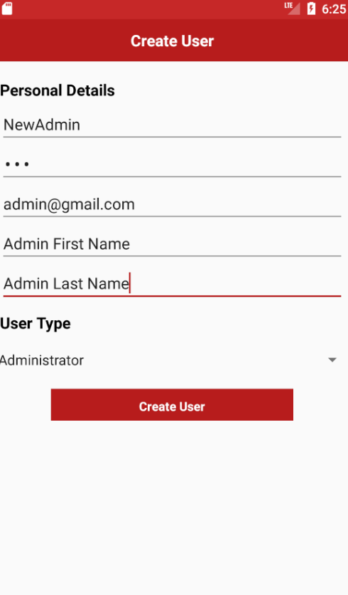

**Enter Personal Employee Details**

Username ( must not already exists )

Password

Email

First Name

Last Name

**Choose User Type**

Admin

Mechanic

**Press Create User Button**

Adds' the new user

# Display Tested Car List

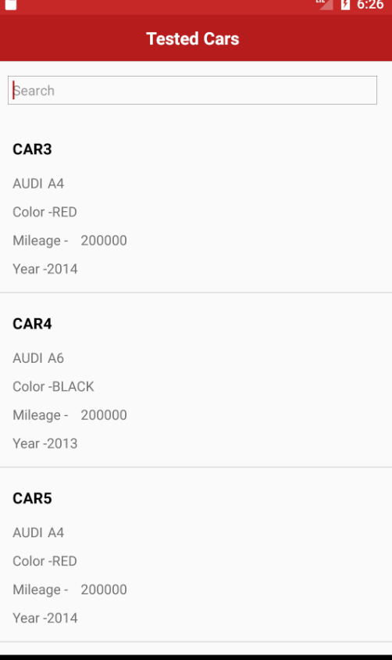

**Search Box**

Enter vehicle plate number to filter tested cars

**Tested Cars**

Press on the chosen car to view their result

# Display Tested Car Results

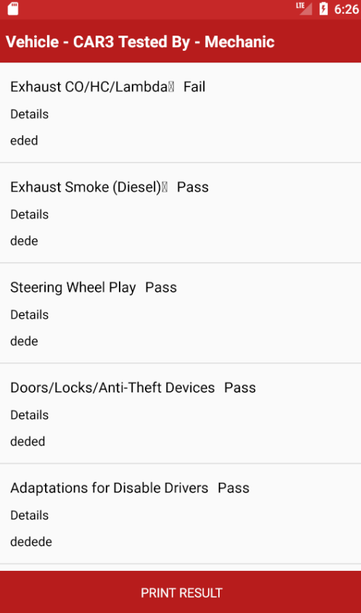

Scroll Up and Down to see all results

**Print Result Button ( doesnt work because I assume printing it via paper? )**

It will print the results of this cars.

# 

# Display Untested Part List

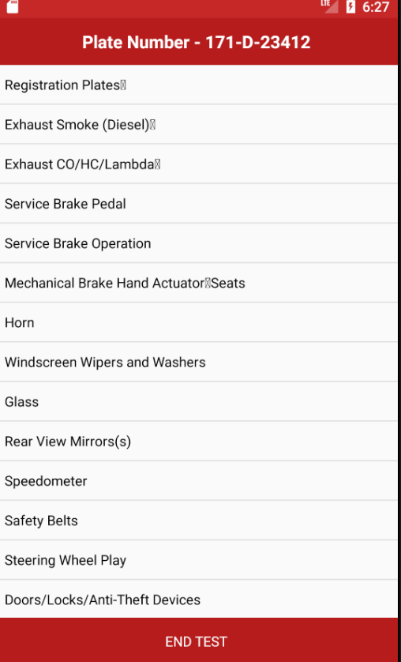

Display the list of untested part list

Click on any of the parts in the list to enter their results

# Insert Part Results

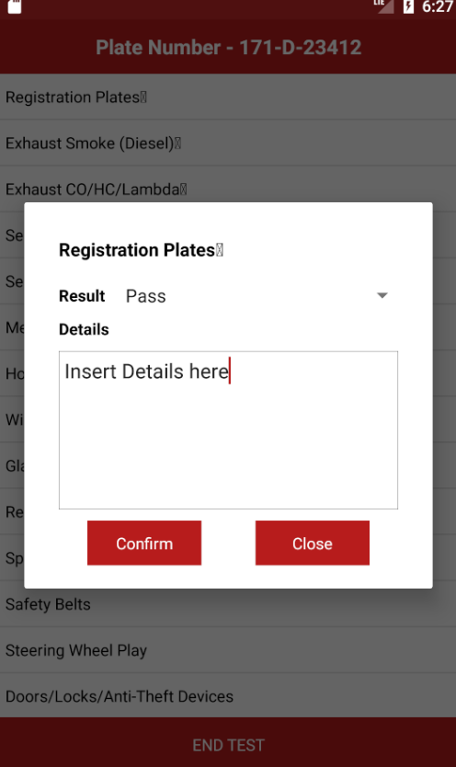

**Choose Result**

Pass

Fail

**Details**

Enter Result Details if needed

**Confirm**

Press to confirm result to be added if clicked the part will be deleted from his list as it's already been tested.

**Close**

Press to dismiss the dialog.